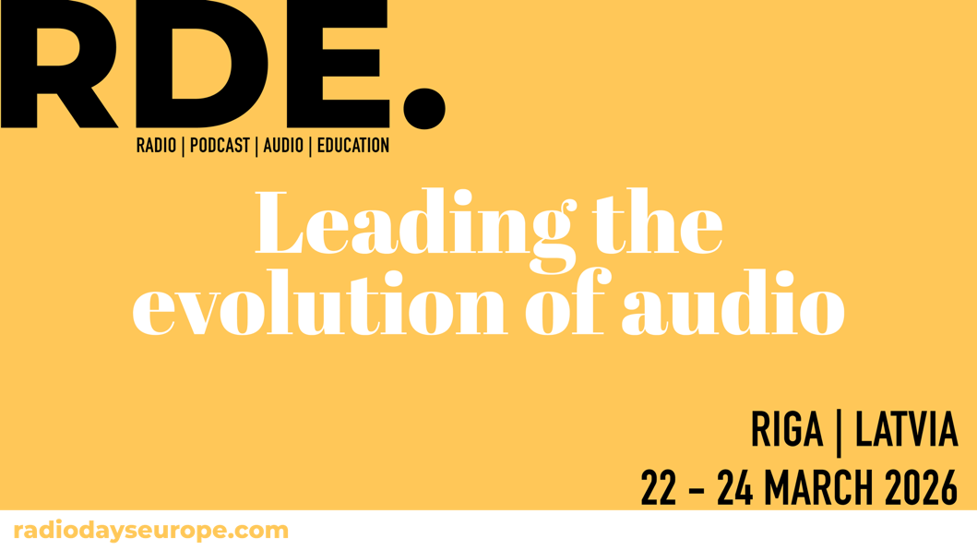

The meeting point for the world of radio, audio & podcast

ATTA Centre, Riga
March 22-24 2026

Event Assistant Information

Thank you for your participation in Radiodays Europe 2026 in Riga!
Here is some practical information about the venue, general information and technical requirements for you as Event Assistants. Please read carefully.

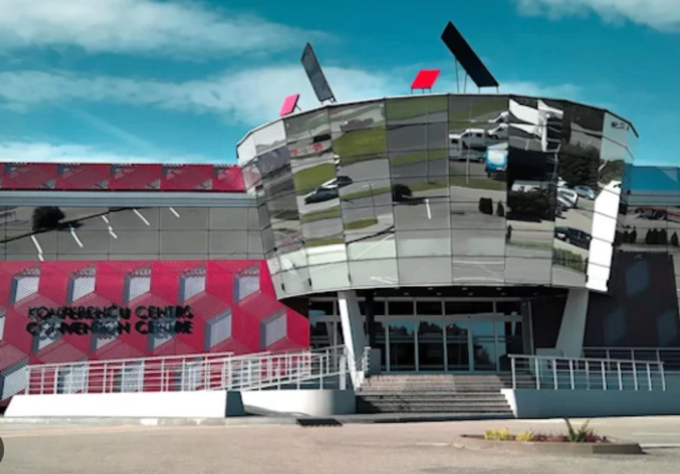

About Radiodays Europe
Radiodays Europe (RDE) is Europe´s largest radio conference and a meeting point for public and private radios and a destination for radio professionals worldwide. Radiodays is held in a different European city each year and the 2025 edition was held in Athens with 1500+ delegates from 60 countries. RDE is organized by a non-profit association, backed by broadcasters in Scandinavia, but supported by EBU, AER, EGTA and other broadcasting organizations in 20+ countries.
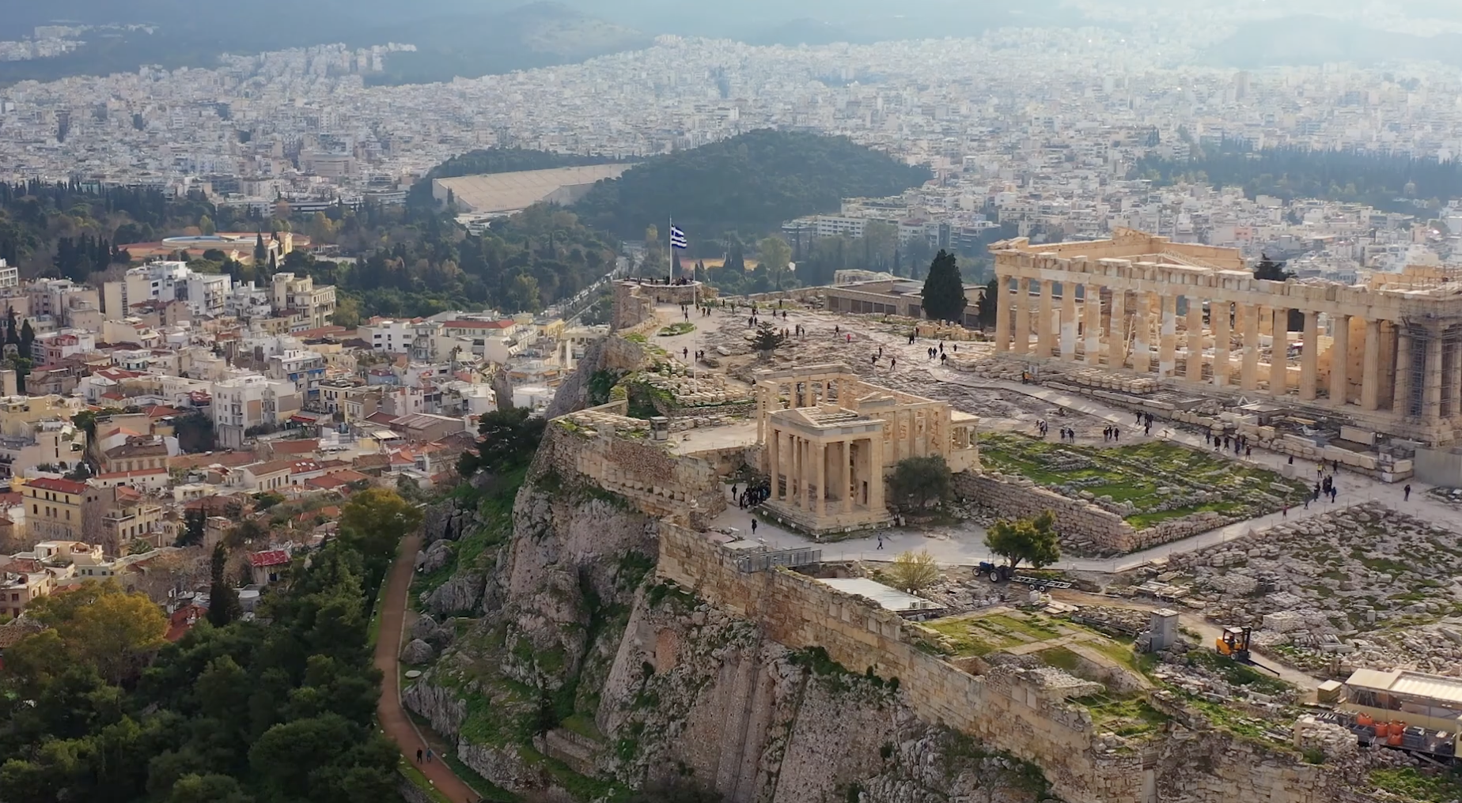
Here's a good round up of
last year – (YouTube Link) >>>>>

Audience
The audience comes from a range of disciplines within the radio industry that include CEOs, station managers, programme directors, music directors, sales and marketing executives, creative teams, digital managers, radio journalists and on-air DJ´s. The audience is equally distributed between public and private broadcasters.

Format
RDE starts on Sunday 22nd of March 2026 with general registration open from 09.00. The exhibition is open from 12.00-17.00 on Sunday. There are also Summits on Inclusion, Podcast, Youth, Programming, Audio Books, Sales and AI and other activities running on Sunday all through the afternoon.

The sessions on Sunday are followed by a drinks-reception in the evening at the venue from 19.00 to 21.00.

The main RDE conference programme runs from Monday 23rd to Tuesday 24th of March 2026. Registration is open at 8.00 on Monday with the opening session starting at 9.00 on Monday, the conference breaks out into five tracks which will run simultaneously during the two conference days.

Venue
Located in the heart of the capital of Latvia, ATTA CENTRE is one of the largest venues in the Baltics for conferences and events. The ATTA Centre offers a world-class venue for Radiodays Europe 2026.

The Event Assistants Roles
There are both Front of House and Bloggers roles.
Front of House – helping delegates find their way, working on the registration desk, looking after the doors to the Tracks, ensuring the event is run smoothly, reporting any issues. These roles work across all activities and some activity working off the main conference site.

Bloggers - Videos – Interviewing/Cutting/Production - Blogging – you will be writing a 300 word piece for our news section on each of the sessions. This should include quotes from the speakers, points of interest, and ensure that you have captured the session as a whole.

https://radiodayseurope.com/blog-right-sidebar/

For video editing, we require one person with video editing software to assist the team in editing down each session and adding tops and tails. These videos will then be posted in YouTube and on our website.

All bloggers and video editors must bring their own laptop or tablet.

Both roles develop a great sense of team spirit and are very rewarding. The roles are quite demanding over the three days and require a good sense of commitment and stamina. You will be given a rota and need to be specific places at the required time, you also need to stay in place. You need to be friendly and welcoming and be alert to peoples interests and needs.

We will set up a WhatsApp group for communications across the conference.

It is also really good fun!

Here’s a picture of some of the team of event students we worked with in Prague:
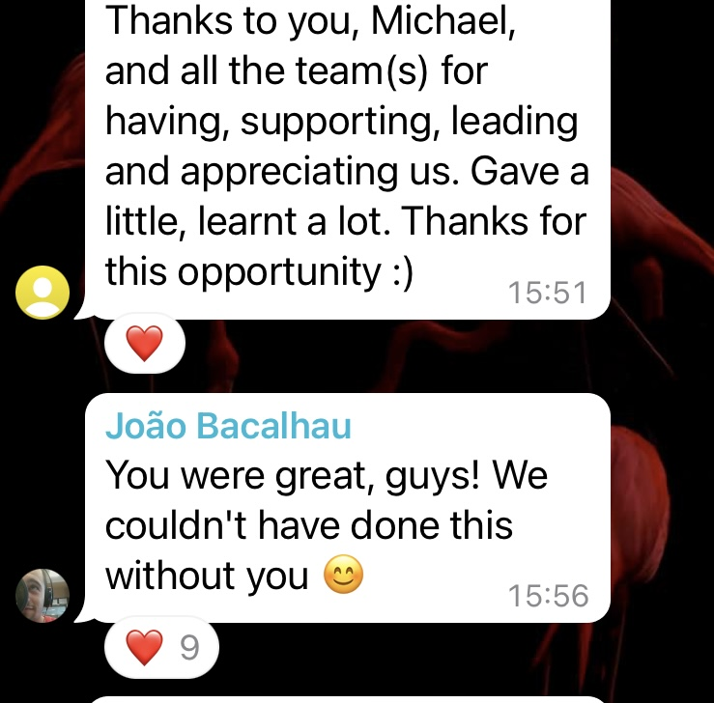

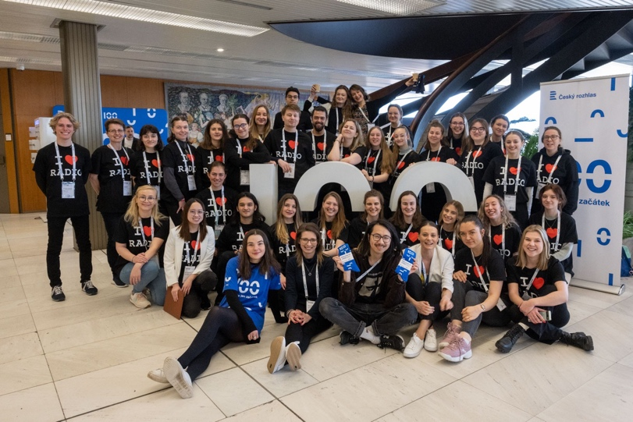
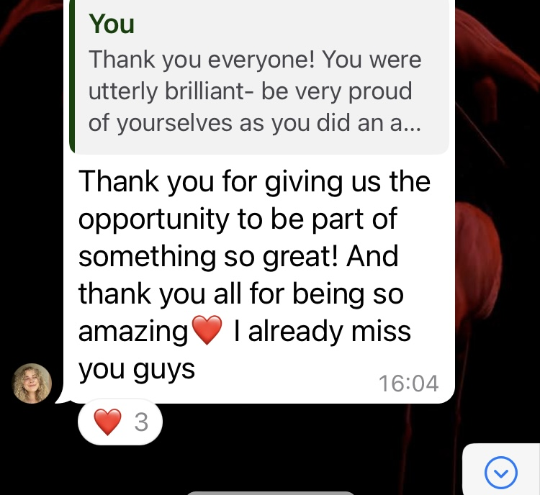

And some of the things they said on our WhatsApp group.

What to Wear
Please wear comfortable practical clothing. A lot of time is spent either in one position or moving across the conference centre. We ask that you wear black trousers or jeans and either black or white practical footwear (eg trainers) so that the look is uniform across the teams and delegates can easily recognize us.

Travel
Public Transport
Public Transport General Information
From Riga city centre to ATTA CENTRE by public transportation Rīgas Satiksme.

- Address: Krasta iela 60, Riga, Latvia - Telephone: +371 20 118 000

By bus

- Bus 12 or 34 – get off at Grēdu iela stop, which is located right next to the building.

- Buses 12, 34, 5432, 6844 – You can also get off at Balvu iela stop, then cross Krasta Street and walk approximately 8 minutes.

By tram

- Tram 7 – get off at Rēznas iela stop and walk around 10–13 minutes along Frīdriķa Street towards Krasta Street.

- The Grēdu iela stop (bus 12 or 34) is the most convenient option.

- From the city centre (Old Town or Brīvības Street area), travel time can vary depending on traffic, so plan some extra time.

Tickets can be purchased in advance via the Rīgas Satiksme mobile app or at ticket machines, for example Narvesen shops.

For up-to-date schedules and route maps, visit: https://saraksti.rigassatiksme.lv

*Radiodays europe does not pay for taxis or transport costs of any kind to and from the venue please note this when making travel plans. Thank you

Arrival for your session

Please arrive at the venue in good time. Please make your way towards the volunteers Room – you will be provided with the much sought after Radiodays Rigas ’26 T-Shirt. We have volunteer changing rooms to leave your bags and belongings. You will be told where you are stationed for the first session, we move people around so that it doesn’t get boring throughout the day.

Conference badge
Please go to the registration desk where you badge will be available for collection.
You will be given a badge holder and lanyard at registration when you show your badge.

Your badge must be worn at all times during the conference and at the social events. Registration is mandatory. Bring a valid id-card/passport.

The Tracks and Rooms
There are Four Tracks across the conference, some have multiple doors and require more than one person to be welcoming delegates.

In addition, there is other activity and meeting rooms across the conference which you may be required to be stationed at.

There is technical staff in all rooms and a host/moderator for each room.

Evening Programme
Evening events are being organised on the Sunday and Monday nights. These have both got limited capacity.

Sunday Welcome Drinks 22nd March at 18.00-21.00.
Welcome drinks reception at 18.00
The event will take place at the venue from 18.00 to 21.00.

Monday 23rd of March from 19.30-23.00
Radio Night will be Monday evening and will take place at a venue off site which is to be confirmed.
Please bring your delegate pass and picture ID to access the venue.
Dress code: Smart casual.
All are welcome to attend this event.

Contacts
Rosemary Smith
General Manager – Communications & Commercial - rosie@radiodayseurope.com

Camilla Kampevold
Administration, registration and Speaker travel arrangements, camilla.kampevold@nrk.no

Nessa McGann
Programme Group Coordinator / Youth Fund nessa@radiodayseurope.com

Rosie Kendrick
Press and Communication Coordinator rose@radiodayseurope.com

Michael White
Partnerships & Finance Manager, michael@radiodayseurope.com

