



TURĪBA UNIVERSITY

DEVELOPMENT STRATEGY
2026-2030



Content
Intoduction 3
Turība University Development Strategy 2026 - 2030 4
Turība University Description of the Environment 5
Strategic Goal and Strategic Directions 2026-2030 9
Strategic Direction No.1 Studies for the Economy (Entrepreneurship) 11
Strategic direction No.2 Science for competitiveness (Competence) 13
Strategic direction No.3 Internationalization for development (Freedom) 16


Introduction

The period from 2020 to 2025 has been a time of change, challenges, and at the same time growth for Turība University. The global COVID-19 pandemic, geopolitical instability in the region, demographic trends, and digitalization have significantly affected the higher education environment in Latvia and Europe. These factors have promoted rapid adaptation, flexible organization of the study process, and purposeful resource management.
During the pandemic, the university ensured continuity of studies by developing remote learning implementation solutions, thereby strengthening digital competencies. At the same time, academic excellence, international cooperation, and internal governance were promoted. Difficult conditions have served as opportunities for innovation, efficiency improvement, and long-term strategic thinking.
With the conclusion of the development period 2020 - 2025, Turība University has strengthened its position as a university oriented toward entrepreneurship, management science, and professional education, with a clear identity and ambitions. Turība University continues to prove itself as a leader, providing practical and theoretical knowledge and promoting the development of business thinking. This is confirmed by the fact that in the year 2025, Latvian employers, for the seventh year in a row, recognized Turība University as one of the three highest-rated universities whose students are offered study programs most relevant to the work environment and industry, as well as the ability to ensure skills for successful integration into the labor market.
The higher education environment continues to change rapidly – competition for students and academic staff is increasing, labor market requirements are changing, and the importance of digitalization and sustainability is growing.
The development strategy for the period 2025 - 2030 marks a new phase in the university’s development. It is based on experience gained in the previous period and purposefully moves toward increasing competitiveness and study quality, developing scientific activity, and promoting international recognition. The new strategy envisages sustainable growth, implementation of innovations, and even closer cooperation with the business environment to ensure the university’s development in line with future challenges and opportunities.

Turība University Development Strategy 2026 - 2030
MISSION: To provide internationally competitive business and management education by developing entrepreneurial, competent, and responsible leaders for the sustainable development of the European economy and society.
VISION: A leader in business and management education in the European applied sciences space.
#Differenthighereducation
VALUES: entrepreneurship, competence, freedom
STRATEGIC DIRECTIONS: studies for the economy, science for competitiveness, internationalization for development.

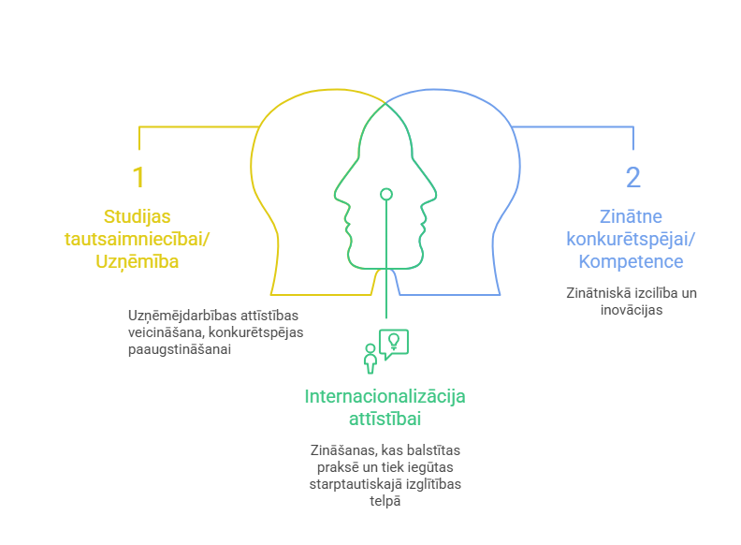

Turība University Description of the Environment
Turība University is the largest private university in the Baltic States. It offers students 33 different study programs representing 7 fields of study. Such a broad offer ensures diverse education opportunities but at the same time requires strategic development planning under changing external conditions. On October 1, 2025, 4319 students were studying at Turība University, which ranks the university 4th among Latvian higher education institutions by number of students.
Picture 1. Number of students studying at Turība University year 2020 – 2025 (October 1 of each calendar year), source: Turība University).
One of the most significant external environmental factors is the demographic situation in Latvia. In recent years, Latvia’s demographic development has been characterized by a long-term population decline, which directly affects the higher education sector and the potential base of local students. According to data from the Central Statistical Bureau, over the last six years the population has decreased from 1.90 million in 2020 to 1.82 million in 2025. A particularly sharp decline was observed in January 2026, when the population was 37 000 lower than in January 2025.
Picture 2. Population of Latvia. Data are given for January of each year. (Central Statistical Bureau).
These overall demographic changes are especially reflected in younger age groups. One of the most serious manifestations is the decline in the number of children and young people, which directly affects the number of secondary school graduates and, consequently, potential higher education students. Estimates from the education sector indicate that the number of first-grade students could decrease by approximately 34% over the next six years if birth or migration trends do not improve.
Additionally, statistical data show that 344 thousand children under the age of 17 make up only about 18.5% of the total population. At the same time, in 2024 only about 11.2 thousand young people graduated from educational institutions with either higher or secondary education. Nearly 42% of secondary school graduates do not continue education, which is a significant indicator for long-term capacity planning in higher education.
Analyzing future trends, forecasts indicate a temporary increase in graduates in 2026 and 2027, followed by a sharp decline, with a predicted 9–10% annual decrease from 2028 to 2030. As a result, competition among higher education institutions for local students will become increasingly intense.
At the same time, changes are observed in young people’s educational choices. Compared to previous years, in the 2024/2025 academic year the number of students simultaneously acquiring vocational basic and secondary education increased by 3.7%. While this provides professional skills earlier, in the long term it may reduce the number of potential higher education students.
Given the demographic challenges mentioned above, the university needs targeted strategic adaptation. As the number of potential students decreases and educational choice habits change, it is essential to ensure:
- sustainable student admission policy,
- study programs adapted to diverse audiences (including lifelong learning),
- active and responsible attraction of international students to balance the decline in the number of local graduates.

Picture 3. Total number of students and number of students in private higher education institutions (according to data of the Central Statistical Bureau)
Transitioning from the demographic situation to the overall structure of the sector, it is also necessary to examine the distribution of students across higher education institutions. According to data from the Central Statistical Bureau, in the 2024/2025 academic year, 74.8 thousand students are pursuing higher education, of which 16.9 thousand study at private higher education institutions, representing approximately 22.6% of the total number of students. Under such conditions of intense competition, a continuous process of development and modernization takes place, following industry trends and market demand.
At the same time, new growth opportunities are also emerging. Based on OECD data, a steady increase in the number of international students can be observed in Latvia. During the period from 2018 to 2023, the share of international students in higher education increased from 9.3% to 13.4%, exceeding the OECD average (7.4% in 2023). Likewise, the report of the Ministry of Education and Science for 2024 indicates that the 2023/2024 academic year began with the highest number of international students to date – 11 542, representing 15% of all students in Latvia. This confirms that Latvia is a potentially attractive destination for international students, and this potential can be purposefully developed by expanding the international student audience, thereby fostering smart immigration.
In addition to the analysis of the external environment, internal quality indicators are also significant. According to a graduate survey conducted by Turība University in 2025, since 2021 the number of graduates who continue working in the field corresponding to their acquired qualification has been increasing. This indicates not only that students are choosing study programs more thoughtfully, but also that the content of study programs corresponds to industry demand. In the future, maintaining close cooperation with industry can further strengthen the relevance of studies and student involvement in entrepreneurship.
Scientific activity plays a significant role in the development of Turība University. In the modern higher education environment, where quality and reputation are increasingly determined by research results, innovation capacity, and international cooperation, scientific and research activity becomes a decisive factor for the institution’s sustainable development and competitiveness.
Competitiveness in science is not only a matter of reputation. It directly affects the quality of studies, the professionalism of academic staff, and students’ opportunities to engage in research. A strong research environment promotes evidence-based study content, the introduction of innovations into the learning process, and the ability to respond quickly to labor market and societal needs.
Considering the increasing competition in the higher education market in Latvia and Europe, it is essential to strengthen one’s identity as a competent and innovative research center. Competitiveness in science allows the university not only to adapt to changes but also to become a driver of them.
By choosing scientific competitiveness as one of its strategic priorities, Turība University confirms its commitment to creating a high-quality academic environment, developing research capacity, strengthening international cooperation, and promoting innovation. This direction serves as a foundation for sustainable growth, strengthening reputation, and creating long-term value for students, academic staff, and society as a whole.

Strategic Goal and Strategic Directions 2026-2030
The university’s strategic goal has been formulated based on a comprehensive analysis of the current situation, as well as an analysis of external and internal environmental factors that affect the university’s operations, development opportunities, and competitiveness. External environmental factors are particularly significant, including demographic trends, labor market development, the dynamics of technology and innovation, as well as globalization and internationalization processes in higher education. The impact of demographic processes, including changes in the number of potential students, as well as increasing competition in the higher education sector, determines the need for the university to purposefully improve its study offerings, increase the efficiency of the study process, and develop new cooperation models with employers and international partners.
At the same time, the strategic goal is closely linked to the results, achievements, and identified challenges of the previous strategy period. By evaluating the implementation of previously set priorities, completed tasks, and areas for improvement, continuity of development and purposeful progress in the next development period has been ensured.
The strategic goal reflects both the university’s accumulated experience and previous development results, as well as the need to respond flexibly to changing external environmental conditions. It serves as a foundation for the university’s further development, strengthening its competitiveness, the quality of studies and research, cooperation with society and the economy, and ensuring sustainable long-term growth.
Strategic goal:
Enhancing international competitiveness in the business and management education ecosystem, ensured by high-quality studies aligned with industry leadership and labor market needs, active integration into the global academic space, geographical and institutional diversification of internationalization, as well as the development of scientific and research activities.
To achieve the strategic goal of Turība University, three main strategic directions have been defined, based on the values of Turība University:
Studies for the economy - Entrepreneurship
Science for competitiveness - Competence
Internationalization for development - Freedom

The implementation of the goals and tasks defined within the strategic directions also results in a broader impact on society and the economy.
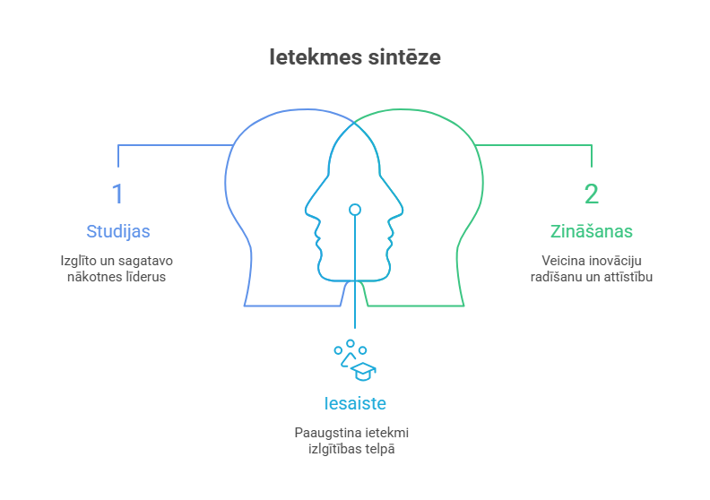
Studies: the university’s faculty inspire, educate, and prepare students as future leaders to create value for both organizations and society as a whole, offering programs from short-cycle courses to master’s and doctoral degrees, covering the full cycle of higher education.
Knowledge: the university is a leading provider of business and management education in the Baltic States. The competencies gained through the study process develop future leaders, professional managers, and specialists in their fields. Faculty members create new theories, methods, insights, and business models to promote the development of the private and public sectors and to enhance societal well-being.
Engagement: the university collaborates with its alumni, builds relationships with public and private sector organizations and other stakeholders, enhancing its impact in the field of education and in the economy as a whole.

Strategic Direction No.1 Studies for the Economy (Entrepreneurship)
The strategic direction “Studies for the economy” is at the core of development strategy of Turība University, ensuring the university’s primary contribution to the Latvian economy – graduates who are competitive and aligned with labor market needs, with practical experience gained during their studies.
To implement this strategic direction, goals and tasks are set to achieve it, structured into six areas of activity.
- Quality of study programs
Goal: to maintain a competitive, economically sustainable, and regularly updated portfolio of study programs.
Objectives established to achieve the goal:
- review the content of study programs regularly, aligning it with labor market and industry needs;
- consolidate study programs and develop academic fields;
- develop specializations within study programs according to external industry and societal demand;
- expand the range of study programs offered in English.

- Student accessibility and performance
Goal: to ensure study accessibility for different target groups and successful completion of studies.
Objectives established to achieve the goal:
- diversify student recruitment channels in Latvia and abroad;
- develop flexible study formats for working professionals and adults (distance learning, enhancement of study materials, micro-credentials);
- reduce student dropout by improving study process management and the student support system.

- Study methods and study process
Goal: to provide modern, practice-oriented, technology-appropriate study methods that develop critical thinking.
Objectives established to achieve the goal:
- to ensure the diversity of teaching and learning methods and their relevance to achieving the results of study programs;
- to integrate artificial intelligence solutions into the study process, observing the principles of academic ethics and human-centered study process management;
- to expand the space for the study process, ensuring learning also in an organizational environment.

- Study environment and infrastructure
Goal: to create a learning environment that supports innovative teaching methods and collaboration.
Objectives established to achieve the goal:
- to develop adaptable classrooms;
- to expand the range of specialized classrooms;
- to broaden the network of collaboration partners for the implementation of the study process;
- to continuously modernize learning spaces.

- Faculty and human resources in studies
Goal: to ensure high academic and professional competence in the implementation of studies.
Objectives established to achieve the goal:
- to establish and develop a center of academic excellence and research;
- to balance faculty workload;
- to reduce faculty turnover;
- to increase the proportion of industry professionals involved in teaching.

- Influence on society and the economy
Goal: to increase the university’s direct impact on society and the economy.
Objectives established to achieve the goal:
- to maintain a high level of graduate employability;
- to develop cooperation with industry associations;
- to increase the relevance of students’ applied research to industry demand;
- to develop the business incubator’s activities, increasing the number of participants and the creation of joint ventures with the university.

Education is not the learning of facts, but the training of the mind to think. /Albert Einstein/

Strategic direction No.2 Science for competitiveness (Competence)
The strategic direction “Science for competitiveness” focuses on strengthening scientific capacity of Turība University, developing applied research, and integrating science into the study process, ensuring competitiveness at both national and international levels.
To implement the strategic direction, goals and tasks are set to achieve it. The completion of these tasks will be measured using various performance indicators, or KPIs (Key Performance Indicators).
- Institutional scientific capacity un evaluation
Goal: to strengthen the university’s scientific capacity in the fields of social sciences and IT.
Objectives established to achieve the goal:
- to consolidate research groups, reducing fragmentation;
- to strengthen institutional support for research;
- to obtain indexing of scientific journal Acta Prosperitatis of Turība University in internationally recognized research publication databases.

- Faculty and student involvement in research
Goal: to integrate research into the study process at all levels of education.
Objectives established to achieve the goal:
- to promote students’ independent research activities;
- to involve students in research projects led by faculty;
- to develop student-led research projects;
- to include students as co-authors in research publications;
- to engage doctoral students in leading research projects.

- Results of faculty research
Goal: to increase the volume of internationally competitive research outcomes.
Objectives established to achieve the goal:
- to increase the number of faculty publications cited internationally;
- to increase faculty participation in international scientific conferences;
- to increase faculty involvement in international research projects;
- to strengthen support for preparing project proposals;
- to develop applied research lines in collaboration with industry;
- to prioritize research aligned with national and EU priorities;
- to promote research visibility and dissemination;
- to increase the number of applied research projects;
- to ensure the implementation of research results in practice;
- to strengthen collaboration with companies and the public sector.

- Visibility and dissemination of research results
Goal: to increase the recognition of the university’s scientific activities.
Objectives established to achieve the goal:
- to increase the number of scientific publications;
- to strengthen the editorial board of scientific journal of Turība University Acta Prosperitatis with international experts;
- to develop the international recognition of the scientific journal Acta Prosperitatis.

- Industry research projects
Goal: to provide tailored research solutions for SMEs and local municipalities.
Objectives established to achieve the goal:
- to sign collaboration agreements for conducting research with industry sectors;
- to increase the number of repeated research.

- Intellectual property and commercialization
Goal: to integrate aspects of commercialization into research.
Objectives established to achieve the goal:
- to promote patent applications;
- to develop intellectual property management;
- to incorporate commercialization aspects into research projects.

- Participation in conferences and scientific mobility
Goal: to ensure researchers’ regular presence in the academic community.
Objectives established to achieve the goal:
- to encourage faculty participation in conferences (local, industry-specific, international);
- to provide funding for conference participation;
- to promote researchers’ international mobility.

- International academic expertise
Goal: to increase the international recognition of Turība University’s academic staff.
Objectives established to achieve the goal:
- to increase faculty participation as both international experts and lecturers;
- to encourage involvement in foreign editorial boards;
- to increase participation of international reviewers;
- to develop the volume of internationally peer-reviewed publications.

- International scientific projects
Goal: to strengthen international research.
Objectives established to achieve the goal:
- to attract foreign researchers and visiting professors for ongoing collaboration;
- to increase participation in scientific projects under Horizon Europe, Interreg, Erasmus+, and other programs;
- to expand the network of international partners.

Knowledge is power that changes the world. /Francis Bacon/

Strategic direction No.3 Internationalization for development (Freedom)
The strategic direction “Internationalization for development” focuses on ensuring the sustainable international development of Turība University by strengthening the attraction of foreign students, academic collaboration, mobility, and international quality accreditation.
To implement this strategic direction, goals and tasks are set to achieve it. The completion of these tasks will be measured using various performance indicators, or KPIs (Key Performance Indicators).
      - Attraction of international students and geographic diversification
Goal: to ensure a sustainable flow of international students with a balanced geographic structure.
Objectives established to achieve the goal:
- to diversify the regions of origin of international students, including European countries;
- to reduce dependence on a single market;
- to develop targeted recruitment strategies.

      - European academic and project collaboration
Goal: to strengthen positions in the European applied sciences sector.
Objectives established to achieve the goal:
- to expand academic collaboration;
- to establish bilateral cooperation with diplomatic missions in Latvia.

      - Prioritization of strategic international partners
Goal: to establish deep, not formal international relations.
Objectives established to achieve the goal:
- to identify priority partners in each field of study;
- to develop joint study and research initiatives.

      - International cooperation outside the EU
Goal: to diversify international cooperation outside the EU.
Objectives established to achieve the goal:
- to develop cooperation with OECD countries;
- to implement projects independently of EU funding.
      - International Mobility
Goal: to promote academic mobility and knowledge transfer.
Objectives established to achieve the goal:
- to increase faculty mobility through Erasmus+ and other programs;
- to ensure knowledge transfer following mobility;
- to develop Erasmus+ mobility;
- to organize international study visits with international business partners;
- to develop double degree programs.

      - International faculty
Goal: to ensure internationalization of the study process.
Objectives established to achieve the goal:
- to increase the proportion of international faculty;
- to develop visiting faculty courses.

      - International accreditations
Goal: to strengthen the university’s international recognition and compliance with standards.
Objectives established to achieve the goal:
- to continue international accreditation processes;
- to prepare study programs for accreditation.
You don't have to be great to start, but you have to start to be great. /Zig Ziglar/

